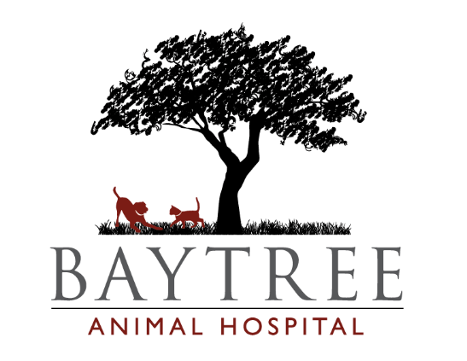

2004 Baytree Road
Valdosta, GA. 31602
229-244-5052

Canine Wellness Annual Visit $112.75
- Comprehensive Exam
- Rabies Vaccine
- Distemper Vaccine
- Parvo Vaccine
- Bordetella Vaccine
- HW Test
- Intestinal Parasite Test

Feline Wellness Annual Visit $95.00
- Comprehensive Exam
- Rabies Vaccine
- FVRCP Vaccine
- Leukemia
- Intestinal Parasite Test

Comprehensive Bloodwork Panel $60.80
Essential Bloodwork Panel $78.86
Premium Bloodwork Panel $118.10

Comprehensive Exam $52.00
Medical Progress Exam $24.00
Brief Exam $36.00
Anal Glands $15.00
Nail Trim $12.00
Bath under 20 lbs $18.00
Bath 20-40 lbs $20.00
Bath over 40 lbs $24.00
Bath cat $20.00

