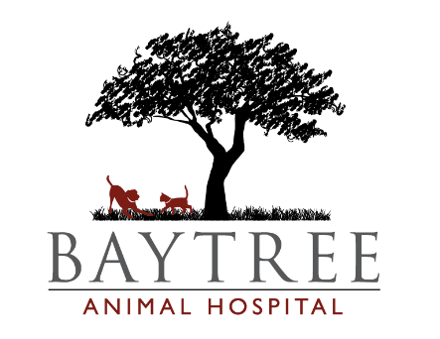
2004 Baytree Road
Valdosta, GA 31602
229-244-5052

For a happy, healthy kitten, Baytree Animal Hospital recommends
kitten boosters to be given 3 to 4 weeks apart.

6 week Kitten Visit $82.20
Comprehensive Exam
Felv/Fiv Screening
FVRCP Vaccine #1
Fecal Exam (microscope reading for intestinal parasites)
Flea and Heartworm Prevention
Dewormer (additional price)

9 week Kitten Visit $69.00
Comprehensive Exam
FVRCP Vaccine #2
Feline Leukemia Vaccine #1
Fecal Exam (microscope reading for intestinal parasites)
Flea and Heartworm Prevention (additional price)
Dewormer (additional price)

12 week Kitten Visit $69.00
Comprehensive Exam
FVRCP Vaccine #3
Feline Leukemia Vaccine #2
Fecal Exam (microscope reading for intestinal parasites)
Flea and Heartworm Prevention (additional price)

15 week Kitten Visit $69.50
Comprehensive Exam
FVRCP Vaccine #4
Feline Rabies Vaccine
Fecal Exam (microscope reading for intestinal parasites)
Dispense 6 months Flea and Heartworm Prevention (additional price)

The first two visits your kitten will require a dewormer to help get rid of any intestinal parasites.
This will be an additional cost of $14 to $23.

